BROTURE
MARUTI PHARMACY COLLEGE , BARGARH

- Maruti Pharmacy College, an unique & fast growing institution in western Odisha, was established in 2004 under the aiges of MSITS trust with the prime effort of Dr. R.N. Moharana (M.pharm, Ph.D) a noted educationist who spent 39 years of teaching experience in degree college of Odisha.
- Our vision and mission is to generate competent pharma human resources.
- To impart quality education in pharmacy with continuous enrichment of knowledge and skill, to inculcate the competitive attitude, leadership quality with ethical approach, to meet the dynamic needs of the global village in all relevant fields.
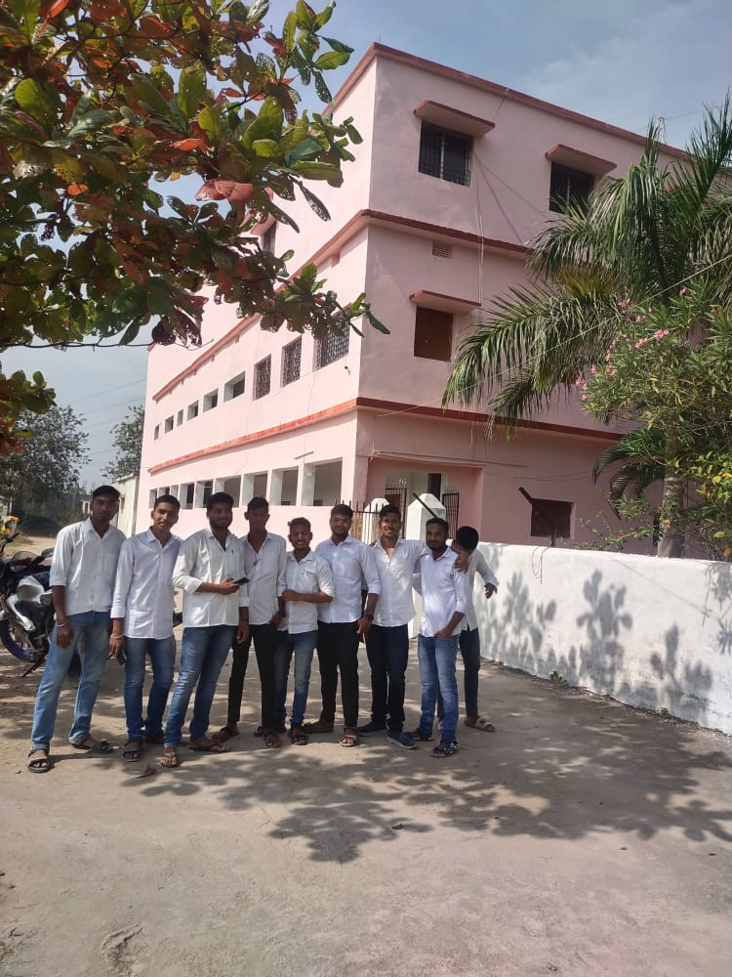

- The institute is imparting D.pharm (60 seats) & B.pharm (60 seats) courses. The faculty members are dully qualified as M.pharm, Ph.D, B.pharm, MCA & etc. With sufficient experience and groomed well to teach both Degree and Diploma students.
- The college is recognized by Govt. of Odisha, approved by PCI (New Delhi) , affiliated to OSBP(Odisha State Board Of Pharmacy) & affiliated to the Odisha University Of Health Sciences, Bhubaneswar.
- The college is situated in a beautiful forestry campus beside 100 Acers of reserve forest. The campus is situated In a healthy atmosphere, well connected to NH-6 & is 5km from the Bargarh bus stand & 7km from Bargarh Railway Station.
- The college has its own land & building with all infrastructure & facilities with fire safety clearance. There are 10 laboratories sophisticated class halls with digitally equipped i.e. projector, smart boards, etc. , building is about 30,000sq.ft.
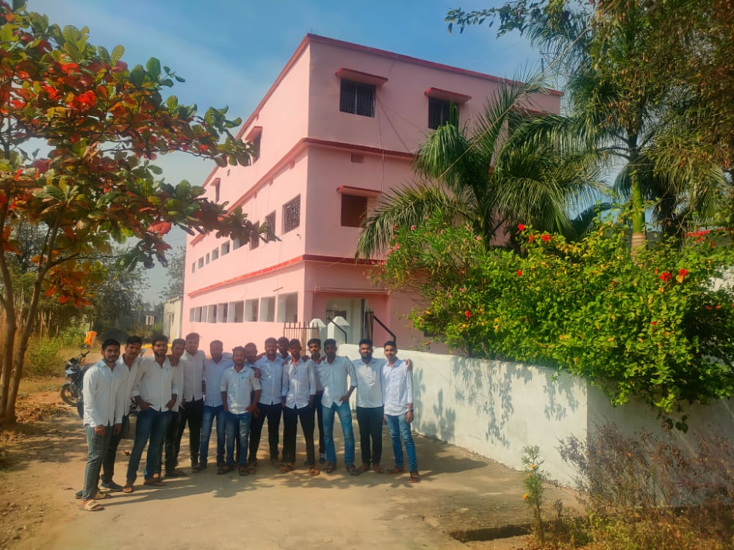

- The Institute is having a digitalised library with reading room, reference room and access to e- library comprising of commuter, internet, printing and photocopy facility. Library is having a number of books with 3500 nos. of National and International scientific journals, nos. of newspaper, magazines, newsletters & subscription to e-journals.
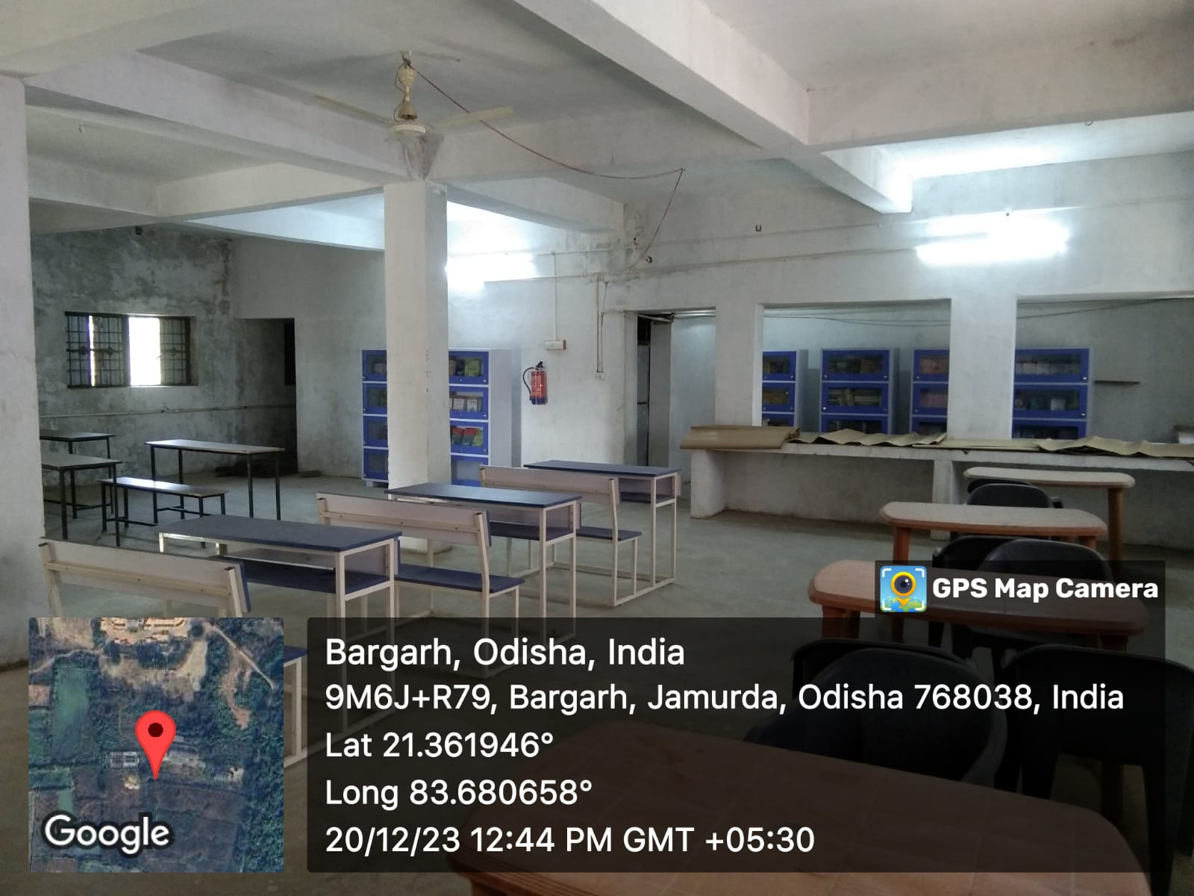

- A well furnished computer laboratory with adequate advanced technology computers with internet facilities.
- MPC, Bargarh, provides hostel facilities for the outstations girl student with in the campus. The rooms are specious with 24hr power backup. Hostel is also sanitary napkin incinerator & cold drinking water facilities.
- An excellent herbal garden with more than 100 varieties of medicinal plants has been maintained for the academic and research purposes

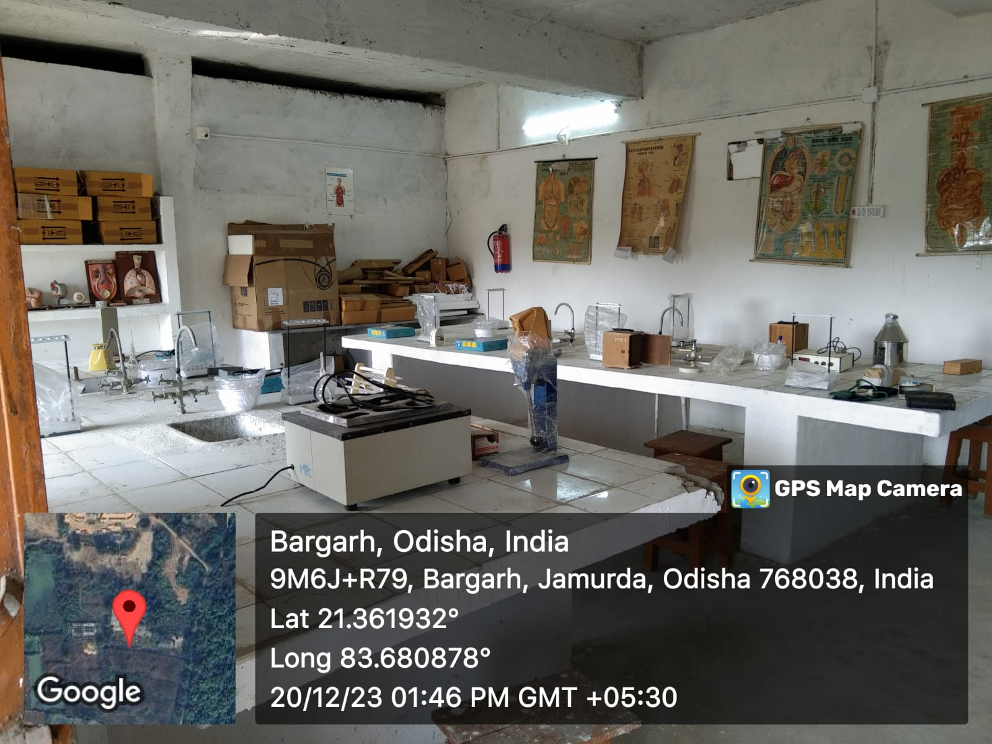
- Scholarship are provided by the central & state government and other organizations to SC, ST, OBC & SE BC, minority & meritorious students as per the criteria mentioned.
- The training and placement cell aims at grooming the students skills, required to perform very well to make them employable.

